Astro 404 HW 7

1. 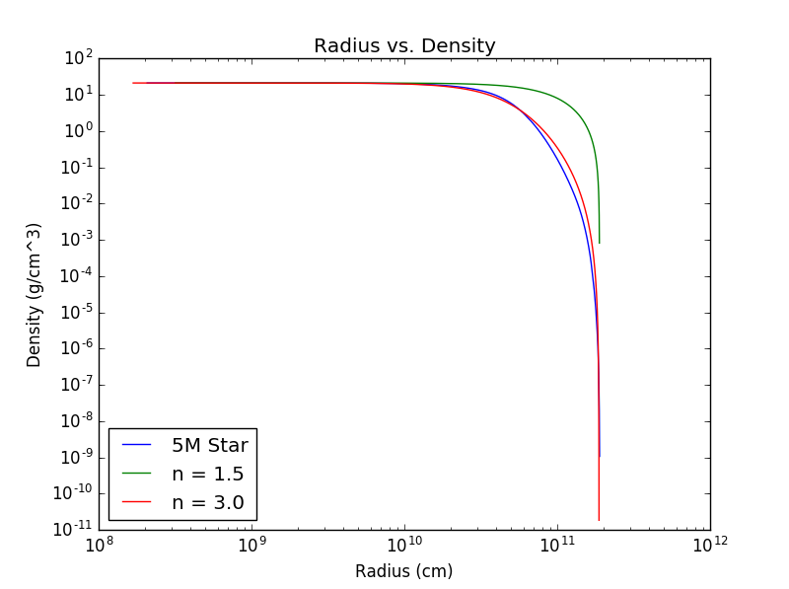

At inner radii both n = 1.5 and n = 3.0 models fit well, but at higher radii the n = 3.0 model fits the best.

1. 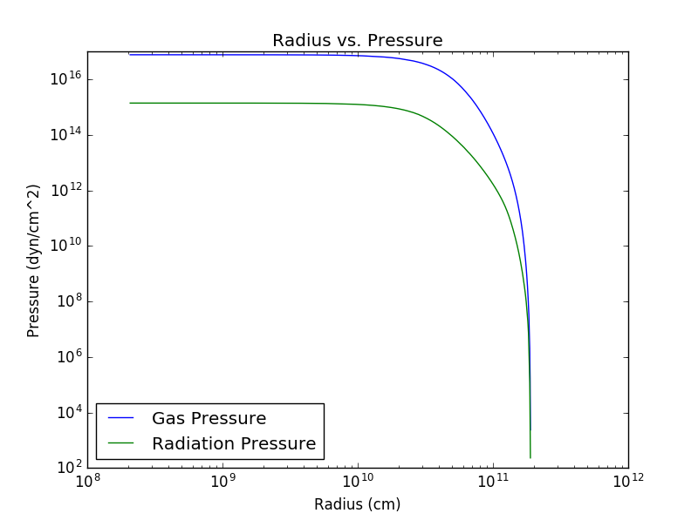
2. Radiation pressure doesn’t dominate.
3. We expect convection cores and radiative envelopes in question #1 where the n = 3.0 model fits. In the Eddington Standard Model, if we examine ηκ, which is approximately constant, then we come to the conclusion that it is a good fit.

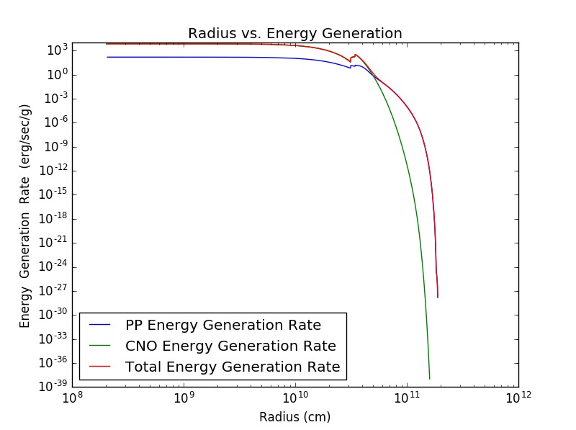

Energy Generation drops to 50% at approximately R = 3\*1010 cm. The main component of the drop is due to the CNO cycle.

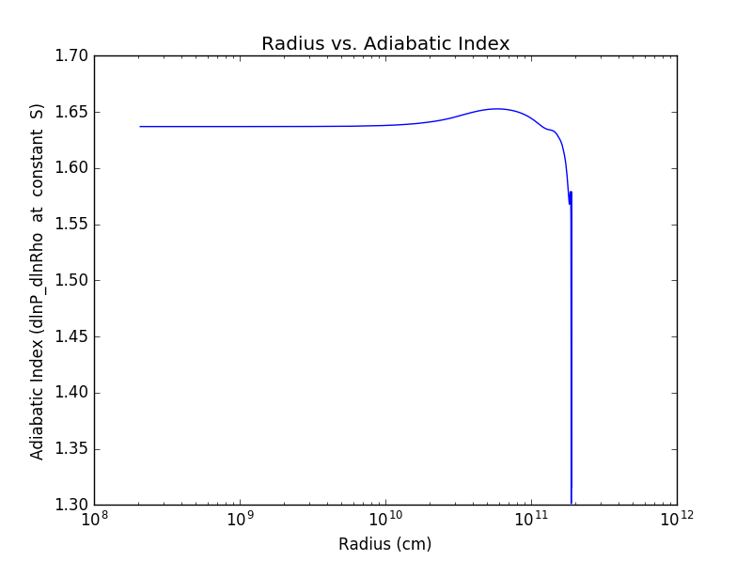

The adiabatic index doesn’t fluctuate. There is hot and ionized gas inside the star. It doesn’t follow this toward the outer regions of the star.

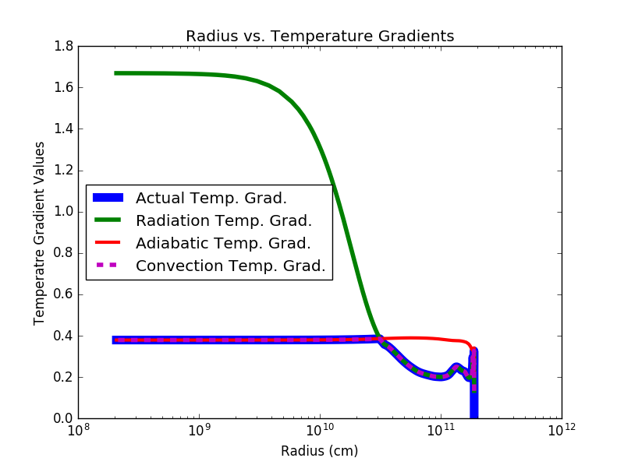

There is a convective region in the star while the radiative temperature gradient is greater than the adiabatic temperature gradient. This convection is efficient because the convective temperature gradient follows the adiabatic temperature gradient. The star switches to radiation when the radiative temperature gradient drops below the adiabatic temperature gradient.